

FURTHER MATHEMATICS
TRIAL EXAMINATION 1
SOLUTIONS 2015

Section A – answers Section B – answers

Core Module 1 Module 2 Module 3 Module 4 Module 5 Module 6
Number Geometry Graphs Business Networks Matrices
Patterns & & related &
Trig Relations Maths Decision

Maths
1. D 1. B 1. C 1. E 1. D 1. B 1. D
2. C 2. B 2. D 2. D 2. A 2. C 2. E
3. D 3. C 3. E 3. B 3. B 3. A 3. D
4. D 4. D 4. A 4. C 4. C 4. D 4. C
5. B 5. D 5. C 5. E 5. A 5. E 5. C
6. A 6. A 6. B 6. C 6. D 6. D 6. B
7. E 7. E 7. E 7. D 7. B 7. B 7. B
8. C 8. E 8. C 8. A 8. B 8. C 8. A
9. A 9. D 9. D 9. D 9. C 9. C 9. D
10. B
11. D
12. D
13. C

Core – Data analysis

Question 1

There are 4 classes which have less than 10% of left handed students. These 4 classes have 4%, 8%, 8% and 9% of left handed students.
The answer is D.

Question 2

We are only interested in those people whose work car is a wagon. We have no interest in what they use at home so we focus on the third column of data .
The answer is C.

Question 3

Draw a diagram.
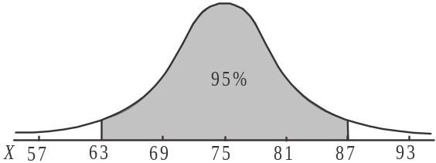
95% of boys will weigh between 63kg and 87kg.
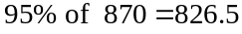.
The closest answer is 827.
The answer is D.

Question 4
We focus on the right hand column which shows those living in a high-rise apartment.
The white block represents people aged between 16 – 55. The percentage is approximately .
The answer is D.

Question 5
The variable age is categorical. This may seem strange because it involves numbers, but they are categories of numbers i.e. 0 – 15, 16 – 55 and over 55. The variable type of housing is also categorical.
The answer is B.

Question 6
It is true that on more than 75% of days in January the website had less hits than on any day in February. This is because the right hand end of the box for January coincides with approximately 1500 hits per day. The minimum value of the February distribution is approximately 1600.
The answer is A.

Question 7
The x values and the approximate corresponding residuals are shown in the table below.

x | 0.6 | 0.8 | 1.2 | 1.7 | 2.0 | 2.4 | 2.8 | 3.4 | 3.8 | 4.4
Residual | + 2 | - 5 | - 4 | + 5 | + 10 | - 4 | + 4 | 0 | - 2 | + 6

The only residual plot that represents this is option E.
The answer is E.

Question 8

Enter the data into your calculator and calculate r. It is
The closest answer is 0.87.
Note that in this question it doesn’t matter whether you assign 2004 as the independent variable (x-values) or the dependent variable (y-values).
It WOULD MATTER though if you had been asked to find the equation of the least squares regression line.
The answer is C.

Question 9

The percentage of the variation in the number of students who tried out in 2014 that is explained by the variation in the number of students who tried out in 2004 is given by the coefficient of determination, 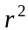, expressed as a percentage.
From Question 8, 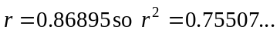
Expressed as a percentage, this becomes 75.507…%
The closest answer is 76%.
The answer is A.

Question 10

The smoothed value for the average monthly maximum temperature in September is given by 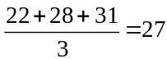.
The answer is B.
Question 11
Start by dividing the 12 pieces of data into three groups of 4 pieces (indicated by the dotted lines).
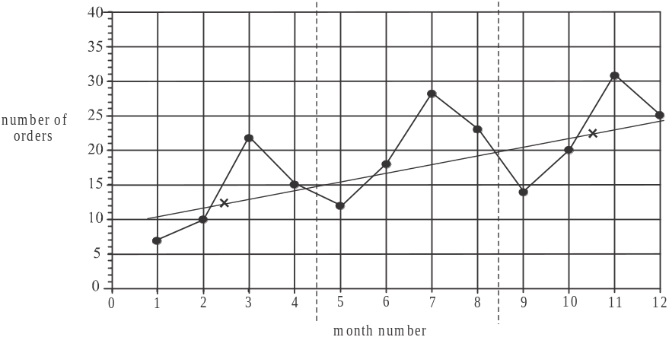

Find the median for the group on the left which is located at approximately 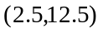 and for the group on the right which is located at approximately 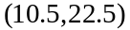. These points are shown as crosses on the diagram above. The straight line drawn through these 2 points IS NOT THE 3-MEDIAN line, but, it has the same gradient as the 3 median line.
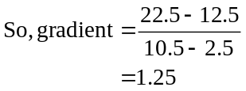
The closest answer offered is 1.2.
The answer is D.

Question 12
Start by finding the quarterly average.
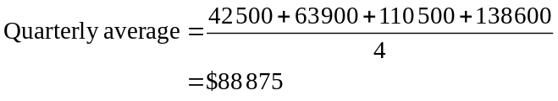
So the seasonal index for Quarter 3 is equal to 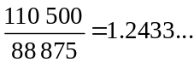
The closest answer is 1.24.
The answer is D.

Question 13
Start by finding the seasonal index for quarter 2.
The three other seasonal indices add to give 2.9. Since the four seasonal indices should add to give 4, the seasonal index for quarter 2 is .
To find the deseasonalised revenue for Quarter 2, use the equation given.
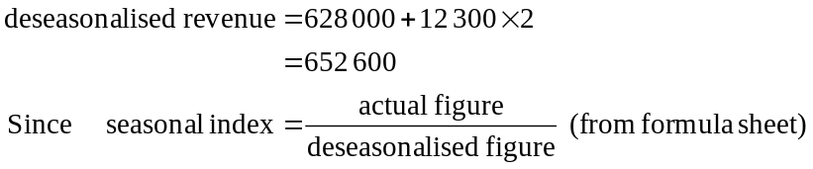
We have, for quarter 2,
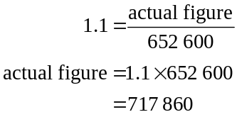
The actual revenue for quarter 2 was $717 860.
The answer is C.
SECTION B

Module 1: Number patterns

Question 1

We have an arithmetic sequence, 30, 50, 70,…
Method 1 – using a calculator
Generate the sequence on your calculator 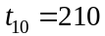
The answer is B.
Method 2
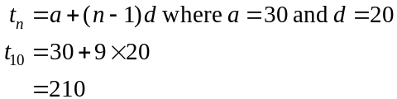
The answer is B.

Question 2

We have a geometric sequence with 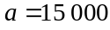, that is, 2015 is taken to be year 1. So 2020 will be year 6. Also, the common ratio for the sequence is .
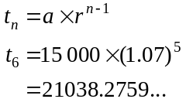
The closest answer is 21 000.
The answer is B.

Question 3

We have a geometric sequence with . Since we can use the sum to infinity formula.
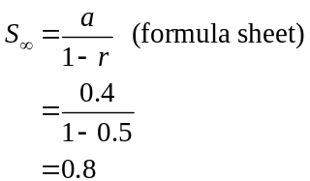
The answer is C.

Question 4

The number of push-ups Bert does at his training sessions forms an arithmetic sequence 5, 8, 11,….
The difference equation will therefore be 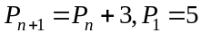 since 3 push-ups are added to the number done at the previous training session.
The answer is D.

Question 5

The sequence generated is a Fibonacci sequence.
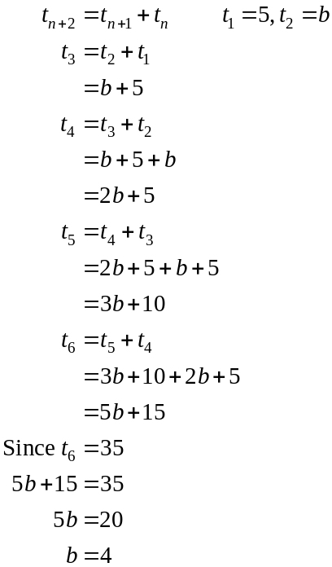
The answer is D.

Question 6

The sequence 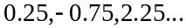 is geometric with
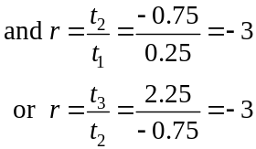
The difference equation will therefore be of the form
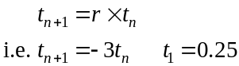
The answer is A.

Question 7

Generate the sequence 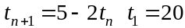
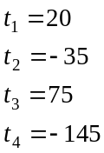
Since 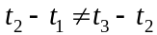 there is no common difference so the sequence is not arithmetic.
The terms are positive, then negative, then positive and so on, hence the sequence is neither increasing nor increasing.
Since 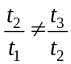 there is no common ratio so the sequence is not geometric.
So the sequence is neither arithmetic nor geometric.
The answer is E.

Question 8

The sequence generated is arithmetic with .
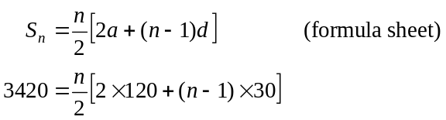
Solve this equation for n, . Since n must be positive, .
It takes 12 hours.
The answer is E.

Question 9

Start by generating the sequence, 30, 36, 37.2, 37.44, 37.488,…
At the start of the third week there is 37.2 tonnes of waste on site so Option A is true.
The amount of waste processed each week is given by 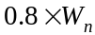. Since 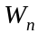 changes from week to week so too will so option B is true.
At the start of the fifth week there should be 37.488 tonnes of waste on site but if the delivery of 30 tonnes hadn’t taken place there would only be 7.488 tonnes so option C is true.
The amount of waste processed each week is given by . If we continue to generate the sequence on our calculator, we see that it converges to 37.5 tonnes, that is, the maximum amount of waste on site is 37.5 tonnes. (This tells us option E is true).
Now so the amount of waste processed each week can be as high as 30 tonnes. Option D is not true.
The answer is D.
Module 2: Geometry and trigonometry

Question 1

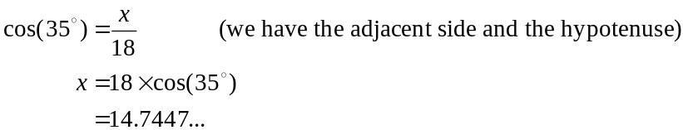
The answer is C.

Question 2

We need to express the two measurements in the same unit i.e. cm.
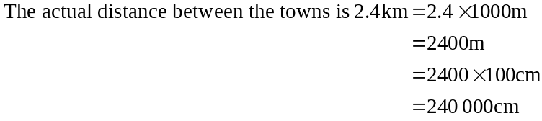
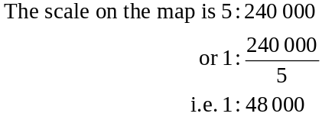
The answer is D.

Question 3
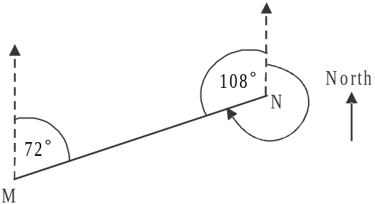
Since the two lines running in a north direction are parallel,
the angles 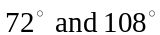 are cointerior angles (and hence
must add to give 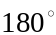).
The bearing of M from N is therefore 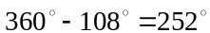
The answer is E.

Question 4

In , average slope or gradient
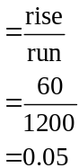
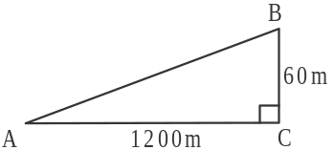
The answer is A.

Question 5

The shaded tile represents half a hexagon.
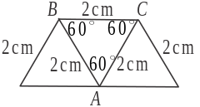
The internal angle BAC equals 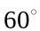 and because
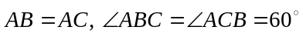.
So is an equilateral and therefore has all sides equal.
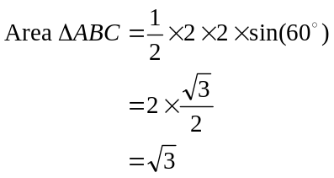
So the area of the shaded, cut tile is 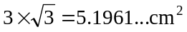.
The closest answer is 5.2.
The answer is C.

Question 6
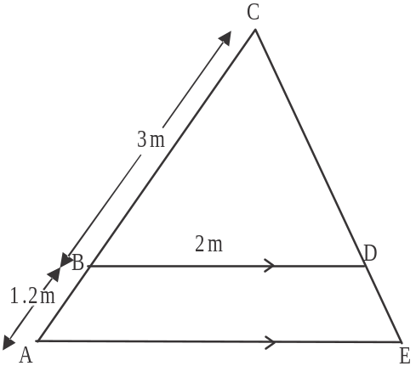
’s ACE and BCD are similar so
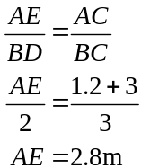
The answer is B.

Question 7

Because we have the 3 side lengths of triangle BCD, we can use Heron’s formula.
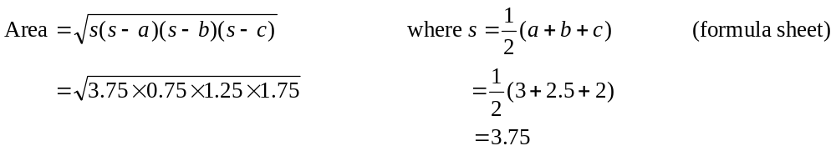
The answer is E.

Question 8
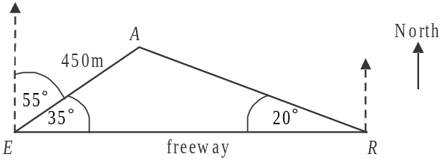
Draw a diagram.
In 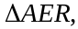
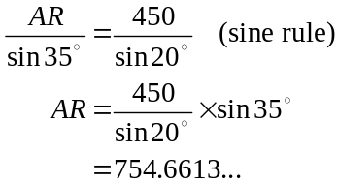
The closest answer is 755m.
The answer is C.

Question 9
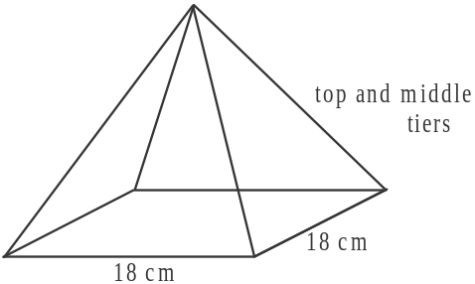
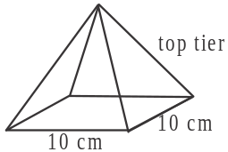

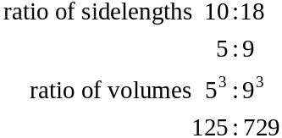
Volume of top tier is 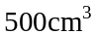.
Let volume of top and middle tiers be x.
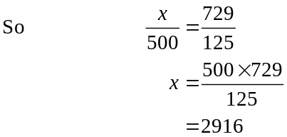
So volume of middle tier alone equals 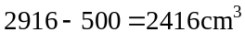.
The answer is D.

Module 3: Graphs and relations

Question 1

A horizontal line has an equation of the form where c is a constant. Since the horizontal line must pass through the point 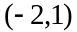, the equation must be 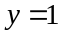.
The answer is E.

Question 2

Looking at the graph, the temperature is below 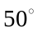C for the first hour and above C for the remainder of the ten hour period. So during 9 out of 10 hours or 90% of this period, the temperature was above C.
The answer is D.

Question 3

The speed of the group is given by the gradient of the graph.
The speed is greatest, when the gradient is steepest and that occurs between 9.30am and 10.00am.
The answer is B.

Question 4

From the step graph we see that the four recommended amounts to be applied are 10g, 25g, 50g and 65g.
The total of 75g could be achieved if Maureen’s trees were 1 year and 4 years, or 1 year and 5 years, or 2 years and 3 years.
The only one of these options given is the last one.
The answer is C.

Question 5

Let the cost of a manicure be $x.
Therefore the cost of a pedicure will be $2x.
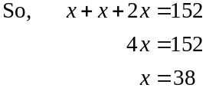
So the cost of a pedicure will be 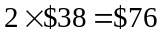.
The answer is E.

Question 6

The gradient of the straight line shown is 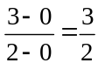.
So the rule connecting x and y is
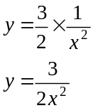
The answer is C.

Question 7

Sandra’s weekly pay can be given by 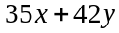. Since she needs to earn at least $1600 per week, we have 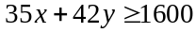
Also, she must work at least as many hours at the hospital as at the private clinic so .
The answer is D.

Question 8
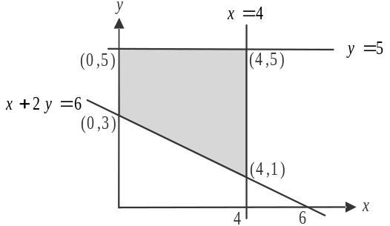
Do a quick sketch.
The feasible region is shaded.
Note that the lines with equations
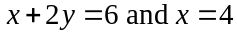
intersect when
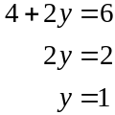
i.e. at the point 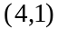.
The other corner points are located at 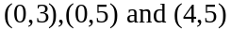.
The answer is A.

Question 9

Method 1
If the objective function C has its minimum value for all the points lying on the line joining the points P and T then it must have the same value at point P and at point T.
The only function for which this is true is D since at point P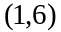, and at point T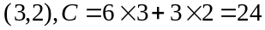.
The answer is D.

Method 2
If the objective function C is to have its minimum value at all the points lying between the points P and T then the family of curves which this objective function belongs to must be parallel to the line 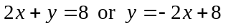. So the gradient of the line must be 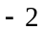.
The only function for which this can be true is 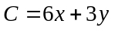
The answer is D.
Module 4: Business-related mathematics

Question 1
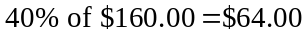
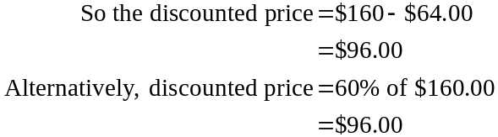
The answer is D.

Question 2
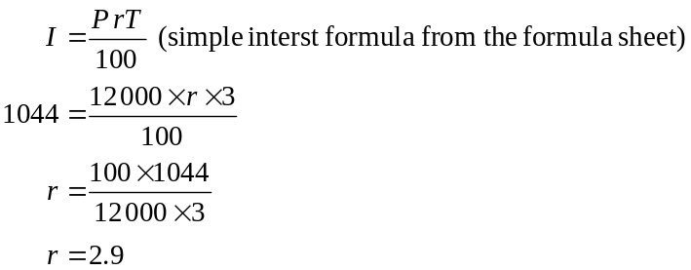
The interest rate per annum is 2.9%.
The answer is A.

Question 3
On Wednesday the cost was $4.
On Thursday the cost was i.e. 10% less than on Wednesday.
On Friday the cost was 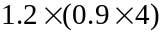 i.e. 20% more than the cost on Thursday.
Note that can be written as .
The answer is B.

Question 4
To find the GST included in the amount, divide by 11.
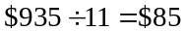
The answer is C.

Question 5
The dryer has depreciated by 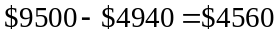
The number of loads it has dried equals .
The answer is A.

Question 6
In total, Sue will pay 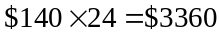.
Note that there is no deposit paid.
So the interest she pays equals 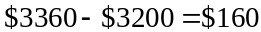.
Use the simple interest formula to find the flat rate.
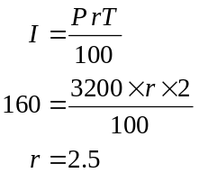
From the formula sheet,.
The answer is D.

Question 7

Using the compound interest formula from the formula sheet, we have
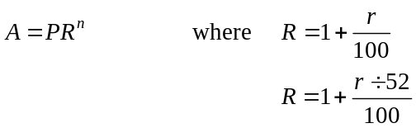
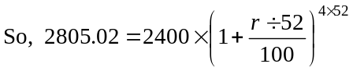
Using your CAS, solve this equation for r.
Clearly the first answer is nonsensical, so
The answer is B.

Question 8

Using TVM, we have
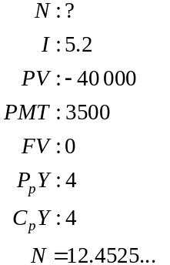
These payments will last for 12.4525… quarters or 3.11… years.
The closest answer is 3.1.
The answer is B.

Question 9

The final payment represents a part payment of a full week.
The proportion of the week is given by 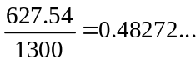
So the number of weeks required for Vesna to completely pay out her home loan is 250.48272… weeks.
Now we can use TVM.
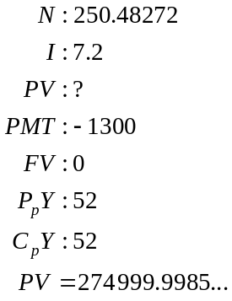
So Vesna borrowed $275 000.
The answer is C.

Module 5: Networks and decision mathematics

Question 1

For a graph to be connected, there must be a path (not necessarily an edge) between each pair of vertices.
For example:
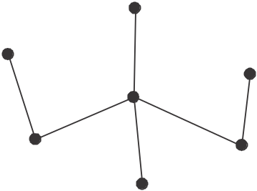

The least number of edges that need to be added is 3.
The answer is B.

Question 2

Go through and mark with a tick those vertices that are reachable and mark with a cross those that aren’t.
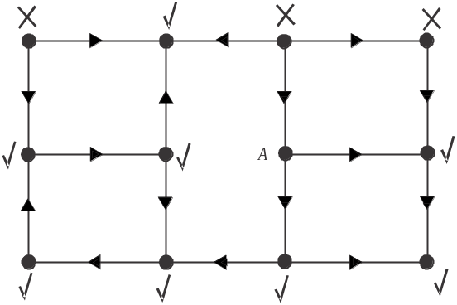

There are a total of 8 vertices (labelled with a tick) that are reachable from vertex A.
The answer is C.

Question 3

Choose the edge with the least distance i.e. 7m. This is the starting edge. Keep adding the edge with the least distance (without forming any circuits) until all the vertices have been reached (ie the graph is connected).
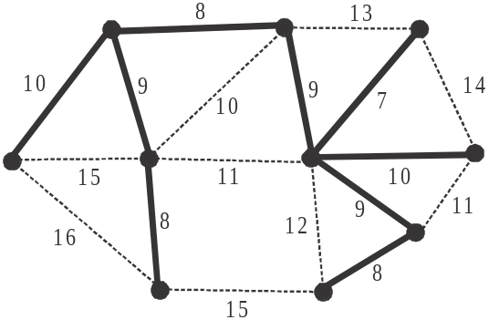

The answer is A.

Question 4

Do a quick sketch of the graph.
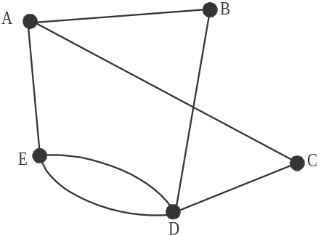

It has 5 vertices, and no loops (which you can tell because the leading diagonal of the matrix contains only zeroes). Also it has no isolated vertices, (i.e. no vertices that are not connected to an edge). You can re-draw the above graph so that no edges cross.
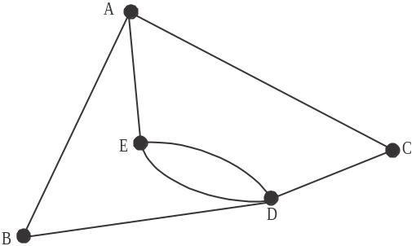

This means that the graph is planar. The graph has 7 edges not 14.
Option D is not true.
The answer is D.

Question 5

For the graph to contain an Euler path it must have two vertices with odd degrees which it has with vertices T and S. Option A is true.
Since no edges cross, the graph is planar. Option B is true.
The graph contains many Hamiltonian paths, for example P Q R S T U. Option C is true.
The sum of the degrees on the vertices is . Option D is true.
Option E is not true because a Hamiltonian circuit must start and finish at the same vertex and visit each of the vertices just once. This is not possible with this graph.
The answer is E.

Question 6

A possible graph is shown.
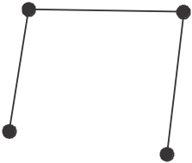

Clearly the graph is planar; that is, the graph can be drawn so that no edges cross. The second statement is true.
Because it is planar, we can use Euler’s formula
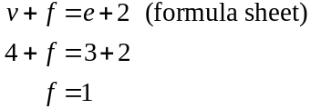
So the graph has one face.
The first statement is true.
If the graph has multiple edges between two vertices then it cannot be connected.
For example.

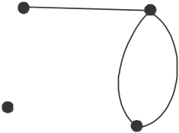

The third statement is not true.
The graph can have all the vertices of an odd degree.
For example.

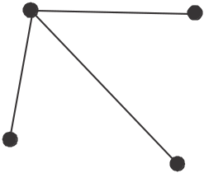

The fourth statement is true. So 3 of the statements are true.
The answer is D.

Question 7

The one-step and two-step dominances of the teams is shown in the table below.

Team | One-step dominance | Two-step dominance | Dominance score
Aces | 3 |  | 8
Blues | 3 |  | 7
Cats | 1 | 1 | 2
Dynamos | 2 |  | 6
Excels | 1 | 2 | 3

From highest to lowest the teams are ranked: Aces, Blues, Dynamos, Excels, Cats.
The answer is B.

Question 8

Option A does not represent the information because task I has only tasks F and J as immediate predecessors. Option B does not represent the information because task C does not have task A as an immediate predecessor.
Option C does represent the information.
The answer is C.

Question 9

Method 1 – trial and error
Make some cuts across the system. Make sure that these cuts separate the two inlet drains from the outlet drain. That is, the two inlet drains must be on one side of the cut and the outlet drain must be on the other side.
A few sample cuts are shown.

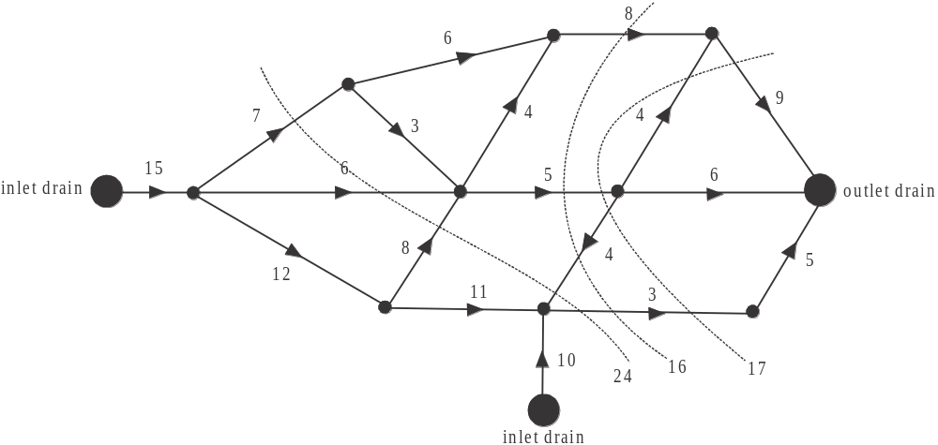

The minimum cut gives us the maximum flow so the minimum cut is 16 and therefore that is the maximum flow.
The answer is C.
Method 2 – tracking the flow
Starting with each of the inlet drains, track as much flow through the system as possible.
Start with the bottom inlet drain.
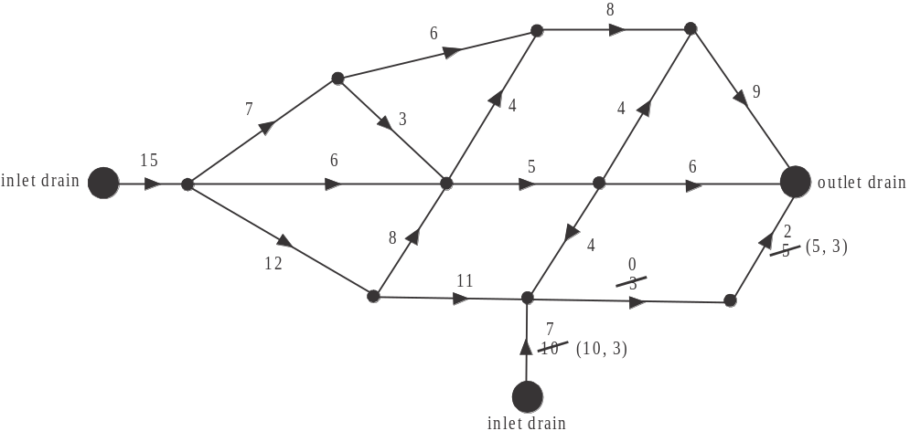

Only 3 litres per hour can get through. Now go to the inlet drain on the left.

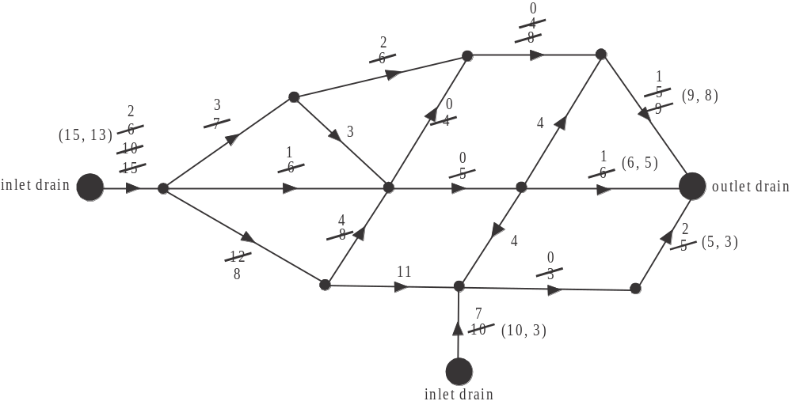

Start by letting 5 litres per hour through.
Then track 4 litres per hour through the system.
Then track another 4 litres per hour through the system.
We have run out of capacity in the system i.e. no more can pass through.

Write down a set of ordered pairs on each edge that is joined to the inlet and outlet drains giving (initial capacity, final flow). The sum of the final flows for the inlet drains is .
The sum of the final flows at the outlet drain is .
The maximum flow possible is 16 litres per hour.
The answer is C.
Module 6: Matrices

Question 1

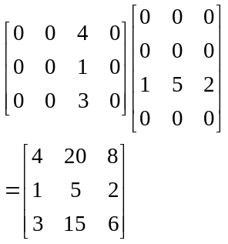
The answer is D.

Question 2

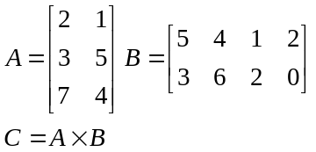
The element in the second row and third column of matrix C can be found by calculating .
The answer is E.

Question 3

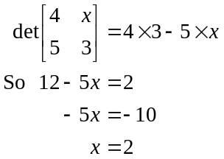

The answer is D.

Question 4

For each of the matrix equations, consider the matrix.
If the determinant of this matrix does not equal zero, then the system has a unique solution.
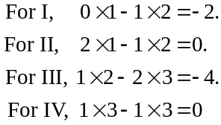
So matrix equations I and III represent systems with a unique solution.
The answer is C.

Question 5

The initial state matrix for January is
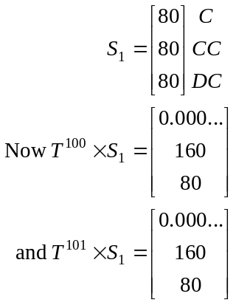
There is no change between the 101st and 102nd month so we assume that a steady state has been reached. You can choose any successive two months, as long as they are reasonably large numbers. The number of customers expected to pay over the long term using a credit card is closest to 160.
The answer is C.

Question 6

For option A, the first matrix is of order and the second is so the resulting matrix is which doesn’t give us the breakdown for each store.
For option B, it is 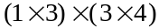, so the resulting matrix is of order and each of the rows of the second matrix represent men’s, women’s and children’s shoe sales which matches the columns of the first matrix.
The answer is B.

Question 7

On Wednesday Craig did a weights session. Locate the W column of the transition matrix. The placement of the 1 in this column indicates that at his next session on Thursday Craig did spin.
Now locate the S column. The placement of the 1 in this column indicates that at his next session on Friday Craig did pump. Continuing in this way, Craig did aerobics on Monday and yoga on Tuesday.
The order therefore, from Monday to Friday, is aerobics, yoga, weights, spin, pump.
The answer is B.
Question 8
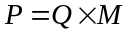
The order of the matrices is 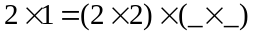.
Matrix M must have 2 rows since matrix Q has 2 columns and matrix M must have 1 column since matrix P has one column, i.e. M has order .
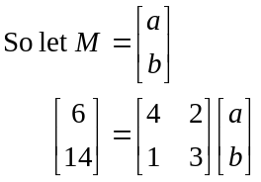
Premultiply both sides by the inverse of matrix Q.
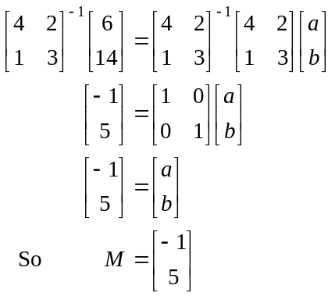
The answer is A.

Question 9
Method 1
Identity matrices must be square so option B is true.
Let I be a 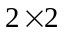 matrix. So A must have 2 columns and AI must have 2 columns. Also. B must have 2 rows and IB must have 2 rows. So option A is true.
B must have 2 rows but could have 1 column so option C is true.
If A had 2 rows and B had 2 columns then E would be true.
B does not have to be a square matrix, so option D is not true.
The answer is D.
Method 2
I is a particular identity matrix.
Identity matrices must be square (option B is true) but they can have different orders e.g. 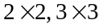 etc.
Let the order of this particular identity matrix be .
Since AI is defined, we have,
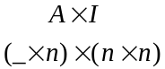
so matrix A must have n columns. Let A have x rows. The order of A is and the order of AI is .
Since IB is defined we have
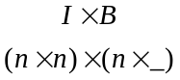
So B must have n rows. Let B have y columns.
The order of B is and so the order of IB is .
So B could be a square matrix if but doesn’t have to be i.e. option D is not true.
It could be a column matrix if so option C is true.
Since AI has n columns and IB has n rows,  is always defined, so option A is true.
The sum of AI and IB could exist if so option E is true.
The answer is D.

